Question 1:
Experiment 1 with n=3
Number of combinations possible is : 2
Best Travel Distance : 156 Best Route : [0, 1, 2, 0]
Elapsed Time : 0.0 seconds
-------------------------------------
Experiment 2 with n=4
Number of combinations possible is : 6
Best Travel Distance : 250 Best Route : [0, 1, 2, 3, 0]
Elapsed Time : 0.0 seconds
-------------------------------------
Experiment 3 with n=5
Number of combinations possible is : 24
Best Travel Distance : 328 Best Route : [0, 1, 2, 3, 4, 0]
Elapsed Time : 0.0 seconds
-------------------------------------
Experiment 4 with n=7
Number of combinations possible is : 720
Best Travel Distance : 220 Best Route : [0, 4, 2, 6, 3, 1, 5, 0]
Elapsed Time : 0.0009579658508300781 seconds
-------------------------------------
Experiment 5 with n=9
Number of combinations possible is : 40320
Best Travel Distance : 376 Best Route : [0, 6, 1, 4, 3, 2, 8, 5, 7, 0]
Elapsed Time : 0.0625920295715332 seconds
-------------------------------------
Experiment 6 with n=10
Number of combinations possible is : 362880
Best Travel Distance : 230 Best Route : [0, 3, 5, 8, 1, 7, 6, 2, 4, 9, 0]
Elapsed Time : 68.87465739250183 seconds
-------------------------------------
Experiment 7 with n=11
Number of combinations possible is : 3628800
Best Travel Distance : 418 Best Route : [0, 3, 1, 9, 10, 4, 2, 8, 7, 6, 5, 0]
Elapsed Time : 8.997973918914795 seconds
-------------------------------------
Experiment 8 with n=12
Number of combinations possible is : 39916800
Best Travel Distance : 420 Best Route : [0, 3, 10, 6, 8, 2, 1, 4, 11, 5, 7, 9, 0]
Elapsed Time : 1576.5879044532776 seconds
-------------------------------------
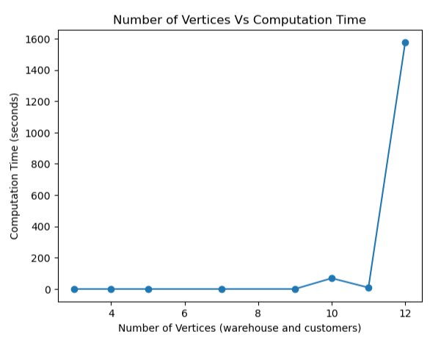
Question 2 :

Experiment 1 with n=3
Best Travel Distance : 156
Elapsed Time : 0.0 seconds
-------------------------------------
Experiment 2 with n=4
Best Travel Distance : 250
Elapsed Time : 0.0 seconds
-------------------------------------
Experiment 3 with n=5
Best Travel Distance : 328
Elapsed Time : 0.0010008811950683594 seconds
-------------------------------------
Experiment 4 with n=7
Best Travel Distance : 220
Elapsed Time : 0.007995367050170898 seconds
-------------------------------------
Experiment 5 with n=9
Best Travel Distance : 376
Elapsed Time : 0.45600295066833496 seconds
-------------------------------------
Experiment 6 with n=10
Best Travel Distance : 230
Elapsed Time : 135.85581302642822 seconds
-------------------------------------
Experiment 7 with n=11
Best Travel Distance : 418
Elapsed Time : 55.59645462036133 seconds
-------------------------------------
Experiment 8 with n=12
Best Travel Distance : 420
Elapsed Time : 7247.610717058182 seconds
-------------------------------------
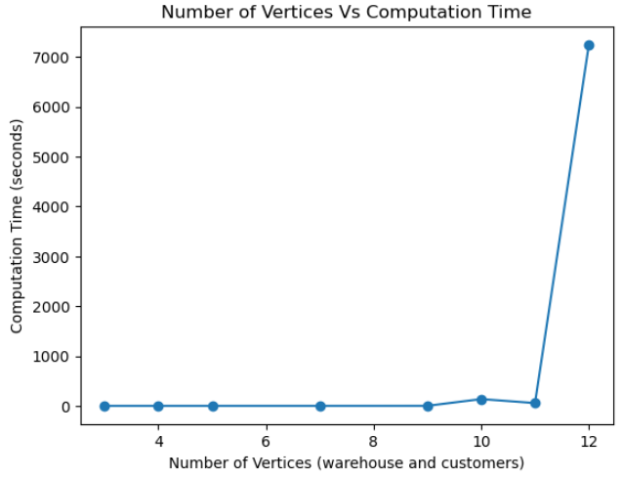
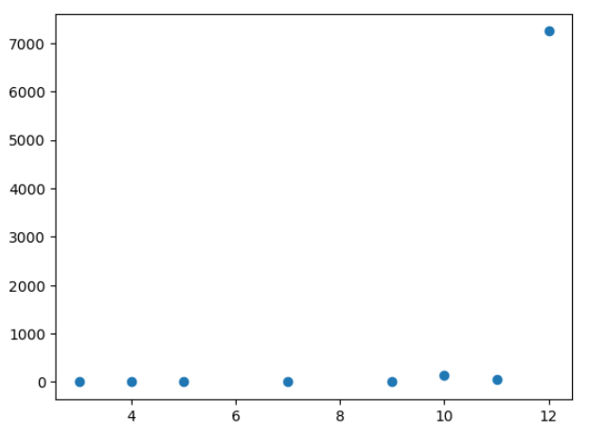

Question 3 :
∑𝑖,𝑗∈𝑆,𝑖≠𝑗𝑥𝑖𝑗≤|𝑆|−1∀𝑆⊂𝑉,𝑆≠∅
For every S which is a subset of vertices, the above constraint ensures that there is no sub tour . Example is lets say i=A, and j =B are two vertices and part of S. Then for cardinality of S is 2, and |S|-1 is equal to 1.
The LHS refers to that sum of X_{AB} + X_{BA} <= 1 , which means we can only one of those routes and not both, which eliminates all the sub tours. For higher subsets of V, which include more that 2 nodes, the same rule applies, when there is one tour between 2 nodes. This ensures also that there is no sub tour in the tour.
2) The formulation is computational expensive based on the number of nodes. For higher number of nodes, the solution space increases polynomial and thus will take more time to solve. For 5 nodes, it should solve easily, but for higher number nodes like 20+ ( a wild guess) I think the computation will be expensive in terms of time.

Question 4 :
I did not use MOSEK as it took too much time to install and I find it difficult to solve it using new syntax. I used Gurobi instead and hope it is ok.
I did 2 runs :
Run 1 without sub tour : The output for the same in terms of time is captured below
Without sub tour :
Output in terms of time :
ilp_exp_times_wo_subtour = [0.015422582626342773, 0.029575586318969727, 0.026371479034423828, 0.029949665069580078, 0.02623271942138672, 0.029648780822753906, 0.020086288452148438, 0.03299903869628906]
There was sub tours in 4 nodes,
<gurobi.Var x[0,3] (value 1.0)>
1.0
<gurobi.Var x[1,2] (value 1.0)>
1.0
<gurobi.Var x[2,1] (value 1.0)>
1.0
<gurobi.Var x[3,0] (value 1.0)>
1.0
Best Travel Distance : 222.0
Elapsed Time : 0.029575586318969727 seconds

There was sub tours in 5 nodes,
<gurobi.Var x[0,1] (value 1.0)>
1.0
<gurobi.Var x[1,2] (value 1.0)>
1.0
<gurobi.Var x[2,0] (value 1.0)>
1.0
<gurobi.Var x[3,4] (value 1.0)>
1.0
<gurobi.Var x[4,3] (value 1.0)>
1.0
Best Travel Distance : 292.0
Elapsed Time : 0.026371479034423828 seconds

There was sub tours in 6 nodes, 9 nodes, 10 nodes, 11 nodes and 12 nodes (pls refer the py file)
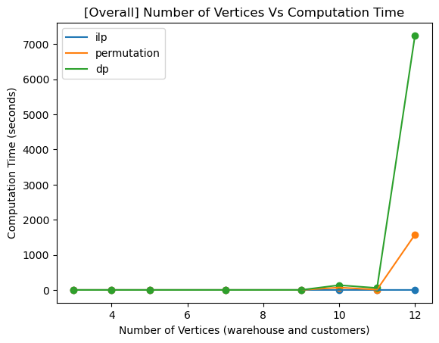
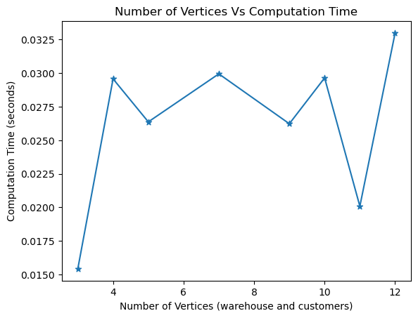
Run 2 witht sub tour : The output for the same in terms of time is captured below
With sub tour :
Output in terms of time :
ilp_exp_times_wi_subtour = [0.0138, 0.0287, 0.02444, 0.0326, 0.0578, 0.08313, 0.1333, 0.2667]
Sub tour eliminated in all nodes ( refer in py file and some examples attached here )
Optimal tour cost: 250.0
<gurobi.Var x[0,3] (value 1.0)>
1.0
<gurobi.Var x[1,0] (value 1.0)>
1.0
<gurobi.Var x[2,1] (value 1.0)>
1.0
<gurobi.Var x[3,2] (value 1.0)>
1.0
Best Travel Distance : 250.0

12 nodes
<gurobi.Var x[0,3] (value 1.0)>
1.0
<gurobi.Var x[1,4] (value 1.0)>
1.0
<gurobi.Var x[2,1] (value 1.0)>
1.0
<gurobi.Var x[3,10] (value 1.0)>
1.0
<gurobi.Var x[4,11] (value 1.0)>
1.0
<gurobi.Var x[5,7] (value 1.0)>
1.0
<gurobi.Var x[6,8] (value 1.0)>
1.0
<gurobi.Var x[7,9] (value 1.0)>
1.0
<gurobi.Var x[8,2] (value 1.0)>
1.0
<gurobi.Var x[9,0] (value 1.0)>
1.0
<gurobi.Var x[10,6] (value 1.0)>
1.0
<gurobi.Var x[11,5] (value 1.0)>
1.0
Best Travel Distance : 420.0
Elapsed Time : 0.2667202949523926 seconds

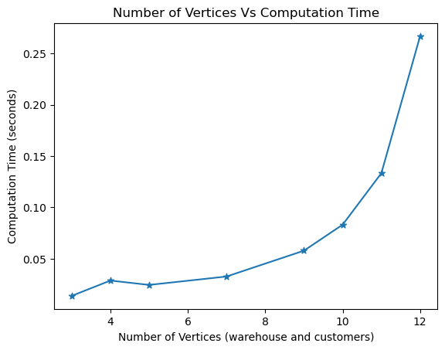.
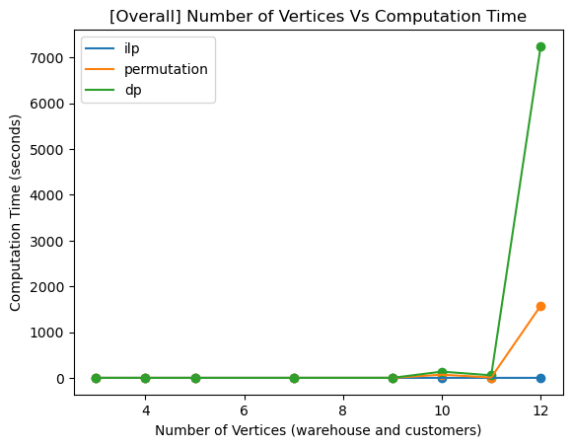

Question 5:
- Explain why sub tour elimination is challenging in the LP relaxation ?
In above sub tour elimination , we can see that since we relaxed the binary constrain on the variable, the sum of the Xij will always be <= S-1 as values will be adjusted by the constraint to allow sub tour and while meeting the above constraint.
The binary relaxation also does not makes sense mathematically as now Xij can take any value between 0 and 1 which does not mean anything. However once we solve we can see the solver only produces values 0 or 1. Thus binary relaxation and with LP we could solve and get integer values. However the sub tour cant be eliminated.
Maybe the above formulation for sub tour elimination maybe hard to implement, maybe there are other formulations for LP that could be implemented.
- Can we obtain n lower bound for the optimal solution using this method ?
In a sense yes. However we need to keep in mind that the solutions will be including sub tours thus logically there is a lower bound solution we can generate. However the solution with no sub tours will be higher than these lower bounds.
- Plot the number of vertices vs execution time plot for the given test instances. The starter code contains the implementation for plotting.
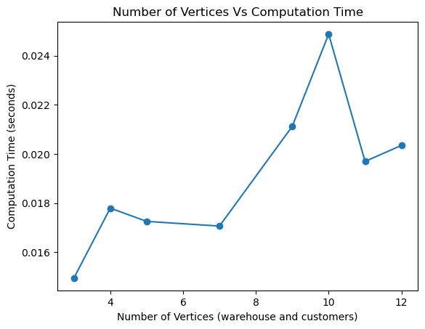
- For all problem instances, compute the gap between the optimal solution computed in Question 4 with the corresponding solution you obtained by LP relaxation (How close the approximation is to the optimal value)
Instance n = | Q4 output (with sub tour ) | Q4 output (no sub tour ) | Q5 output | Gap  (Q4 no tour/Q5)
3 | 156 | 156 | 156 | 1.00
4 | 222 | 250 | 222 | 1.126
5 | 292 | 328 | 292 | 1.123
7 | 162 | 220 | 162 | 1.358
9 | 324 | 376 | 324 | 1.160
10 | 130 | 230 | 130 | 1.77
11 | 292 | 418 | 292 | 1.431
12 | 358 | 420 | 358 | 1.173
Here we can see that at lower number of nodes, there are gaps that are very low but as the nodes increases we can see that the gap increases.

Comparing all the models we can see the following
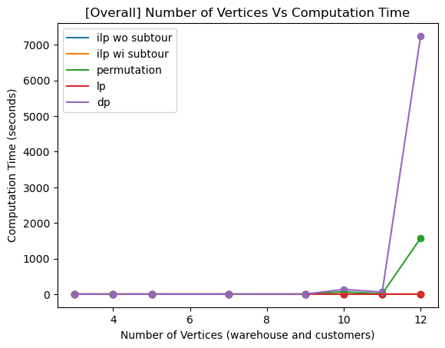
The times are noted here :
permutation_exp_times = [0,0,0,0.001,0.062,68.87,8.99,1576.58]
dp_exp_times = [0.0, 0.0, 0.001, 0.008, 0.456, 135.86, 55.6, 7247.6]
ilp_exp_times_wo_subtour = [0.015, 0.0295, 0.0263, 0.0299, 0.0262, 0.0296, 0.0201, 0.033]
ilp_exp_times_wi_subtour = [0.0138,0.0287,0.02444,0.0326,0.0578,0.08313,0.1333,0.2667]
lp_exp_times = [0.0149,0.0177,0.0173,0.0171,0.021,0.025,0.0197,0.0203]

The LP , ILP models takes lot lesser time to solve TSPs. The DP takes a lot of time to solve especially when the models are larger.

